- What do you need to consider when you make a prediction? ______________________________________________________________________________
- What is an inference? ____________________________________________________________
- Label the plot chart.
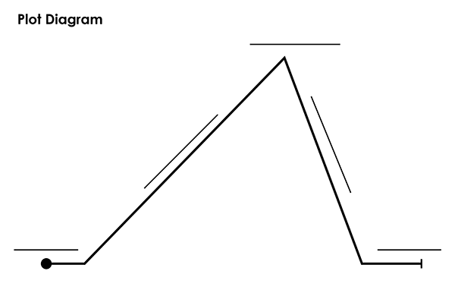

- What is the main idea of a story? What should it include? ____________________________________________________________________________________________________________________________________________________________
- What is the theme of a story? What are some examples? ____________________________________________________________________________________________________________________________________________________________

- Which type of noun is ALWAYS capitalized? __________________________________________
- What is a pronoun? _____________________________________________________________

- Name the 3 types of Point of View and write a sentence using each.

